Make the following sentences that are in singular into plural by changing the underlined noun(s) into plural and changing the verb accordingly .

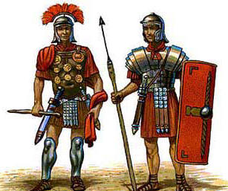
A Roman soldier was the best trained soldier in the world.
Roman soldiers were the best trained soldiers in the world.

In the Roman Empire, the city was the center of government and trade.

In this time, if a man wants to become a Roman citizen, he becomes a soldier.

A student was supposed to learn about Latin and Speech, but not about science or math.

Make the following sentences that are in the present tense into past tense.

In the coliseum, man fights against animals.
In the coliseum, man fought against animals.

Caesar is a Roman general.

You know a little bit about Caesar already.

He wins a lot of battles in Gaul.

He makes it so that Gaul is a part of Rome.

After Caesar is fighting the Gauls, he fights other Romans.

He loves Cleopatra.

Cleopatra says that he is the father of her son.

Put the following sentences together into one conditional clause of the type named.

The senators do not kill Caesar. He becomes Emperor. (Type II)
If the senators did not kill Caesar, he would become Emperor.
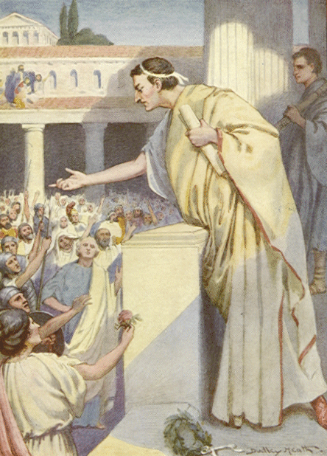
You have learned about Rome. You know who Cicero is. (Type I).

Caesar has an opposite. It is Cicero. (Type II).

Cicero wants something done. He makes a speech about it. (Type II).

Caesar wants something done. He goes to war. (Type I)

